
CONFIDENTIAL
Information memorandum
Elements Property Styling
An established Canberra staging business, offered as the owner retires.

From the owners’ portfolio
Queanbeyan warehouse · Canberra and surrounding region · September 2026
Asking price $500,000

1. Snapshot
Elements stages homes for sale in Canberra, Queanbeyan and nearby districts. Vacant houses, partial styling where the vendor is still living there, consultations, Style to Stay packages, and display work for builders and developers. The stock is owned, not hired in. The warehouse is rented. The vehicles are owned.
Asking price | $500,000
Income FY2023 / FY2024 / FY2025 | $423,175 / $494,880 / $349,411
FY2025 reported result | Loss of $126,029 · normalised EBITDA about $26,209
Plant and equipment (cost) | $416,495 at FY2025
Warehouse | 444 m², Queanbeyan, leased
Vehicles | Hino furniture truck and two other vehicles
Homes the stock can dress | About 30–37 at once, depending on the mix of older and newer houses
On the floor now | 19 campaigns (as at mid-September 2026)
Core work | Real estate agencies, led by Independent Property Group, Blackshaw, Ray White, McCann and Francis
Handover | Up to three months, including introductions
Why it is for sale | The working owner is retiring. Family in Brisbane.

This is the second time the operation has changed hands. Linda Cheng started it in 2016. The current working owner, Tricia, was on the tools for three years, then bought it, and has run it for about five years. The next owner is not buying a brand-new idea. They are buying a shed, a truck, a book of agents, and a short period of Tricia’s time.
2. What you are actually buying
Furniture can be ordered. A Hino can be financed. What takes the years is the phone that rings because an agent already trusts the install. Elements has that book. In a sample of 150 quotes and jobs from the last year, work came from more than twenty sources. Independent Property Group was the largest at 55 jobs — about 37% — and that work is spread across several agents, not one person. Blackshaw, Ray White, McCann and Francis sit behind them. Builders, a developer, Uniting, and private vendors sit in the tail.
Those relationships sit with Tricia today. She will introduce them. Whether they stay is then the buyer’s work. That is the honest version, and it is still a proper reason to buy a going concern rather than a truckload of sofas.
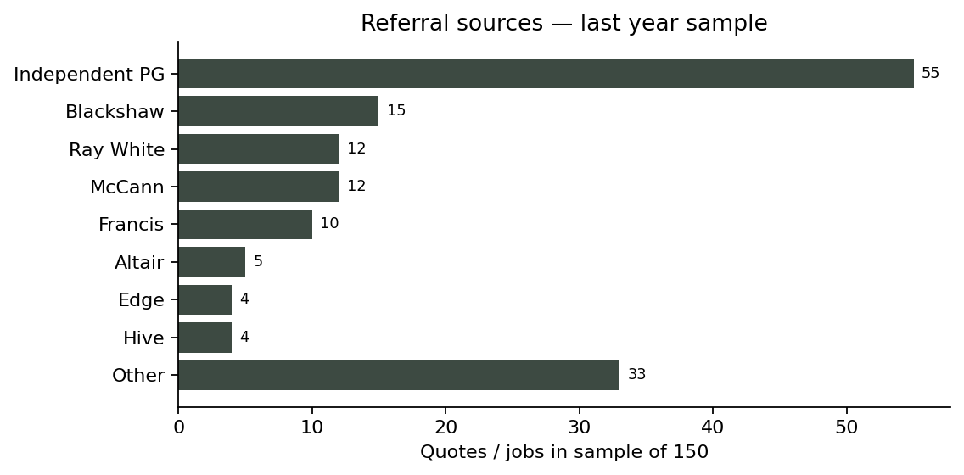
Counts from the owners’ sample of 150 quotes and jobs. Percentages recalculated from those counts.
Referral source | Jobs | Share
Independent Property Group | 55 | 36.7%
Blackshaw | 15 | 10.0%
Ray White | 12 | 8.0%
McCann Properties | 12 | 8.0%
Francis Properties | 10 | 6.7%
Altair Property | 5 | 3.3%
Edge | 4 | 2.7%
Hive Property | 4 | 2.7%
Uniting / Community | 3 | 2.0%
LJ Hooker | 3 | 2.0%
Freelance agent and private | 3 | 2.0%
Raine & Horne | 3 | 2.0%
Home by Holly | 3 | 2.0%
Rapport Property | 2 | 1.3%
Fuse Property | 2 | 1.3%
McIntyre Property | 2 | 1.3%
Corporate / builder / partner | 2 | 1.3%
Momentum | 2 | 1.3%
AM Property Agency | 1 | 0.7%
The Parade | 1 | 0.7%
GEOCON | 1 | 0.7%
Wright Dunn | 1 | 0.7%
Carter & Co | 1 | 0.7%
Verv | 1 | 0.7%
MARQ | 1 | 0.7%
Sutton | 1 | 0.7%
Total | 150 | 100%

3. Money
Turnover reached $494,880 in FY2024. FY2025 fell to $349,411. The owners say that was fewer working days while family had babies, not a collapse in the stock or the agents. The reported loss of $126,029 includes depreciation of $66,253, interest of $25,680, bad debts of $20,655, and other items they treat as non-operating. On their add-backs, normalised EBITDA is about $26,209. A buyer will want the full P&L, BAS and add-back file under due diligence. Nothing in this memorandum is a forecast.
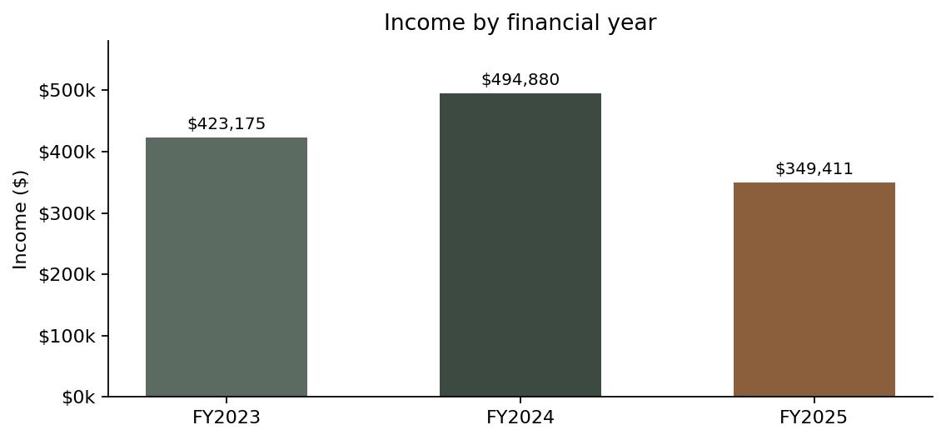
 | FY2023 | FY2024 | FY2025
Income | $423,175 | $494,880 | $349,411
Plant and equipment (cost) | $344,839 | $414,165 | $416,495
Minor plant expensed | — | $20,378 | $13,146

Plant and equipment on the books rose by about $69,000 in FY2024 as stock was refreshed. Minor items were also expensed. The owners’ point is fair: a buyer is not starting from an empty warehouse. The stock is there, including pieces that suit older Canberra houses as well as newer ones. Utilisation is the lever. FY2024 shows what the same shed can do when it is busy. FY2025 shows what happens when the owner is not.
The asking price is $500,000. At that number, last year’s normalised earnings are not the story. Replacement cost of the inventory and vehicles, a live book of work, and the cost of not having to assemble a 444 m² operation from scratch — that is the story a purchaser should test in due diligence.
4. The shed and the truck
Operations run from a 444 m² warehouse in Queanbeyan. Secure storage, picking, and staging before a job goes out. A purpose-built Hino furniture truck does installs and collections. Two other vehicles cover quotes and site visits. Documented quoting, scheduling and inventory allocation sit behind that. The owners put concurrent capacity at about 37 homes. In mid-September 2026, 19 were out. A mixed book of older and newer houses is what makes the top end realistic — not every lounge in the rack is modern.
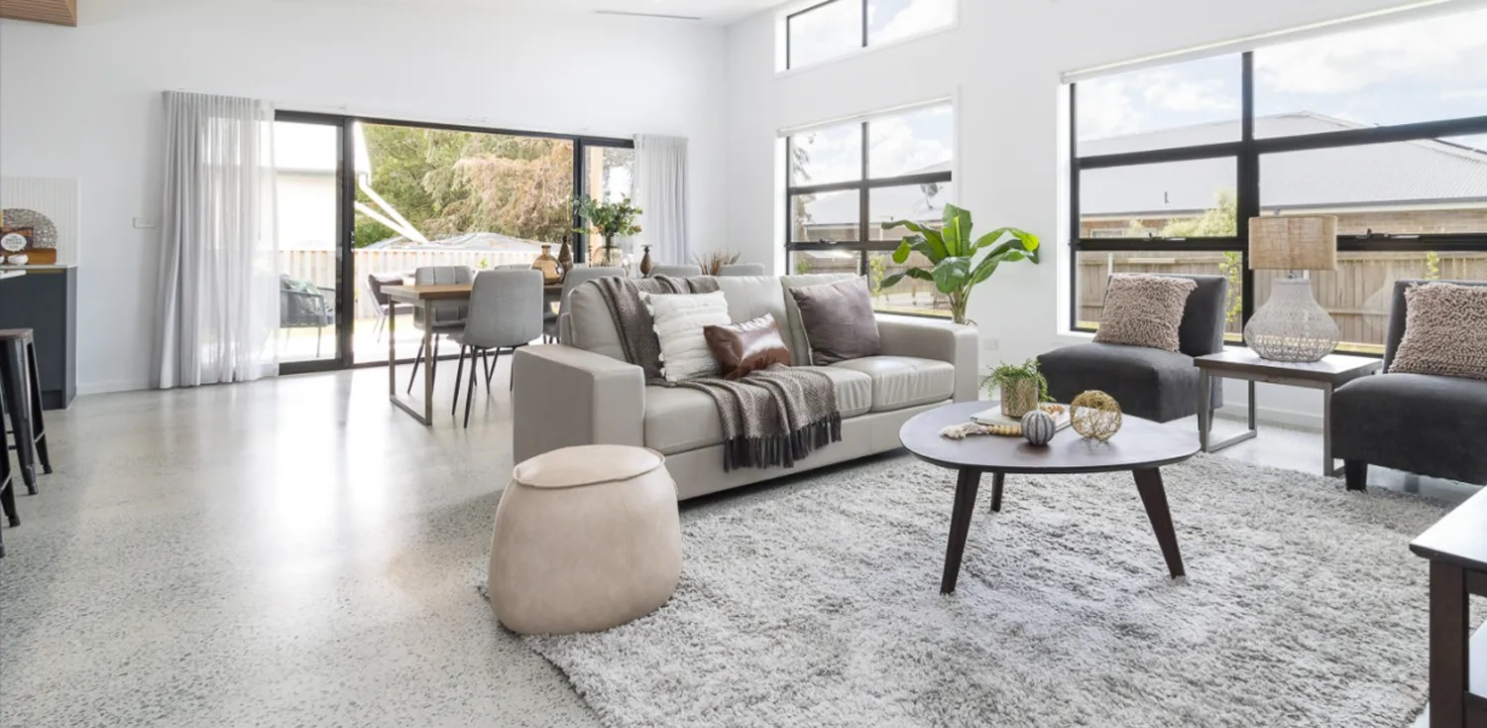 | 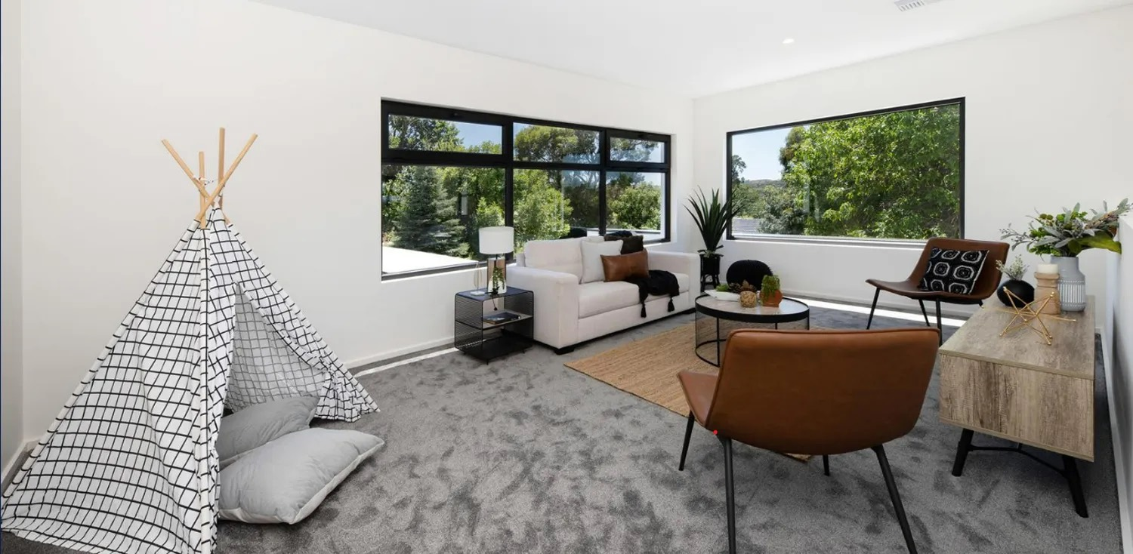

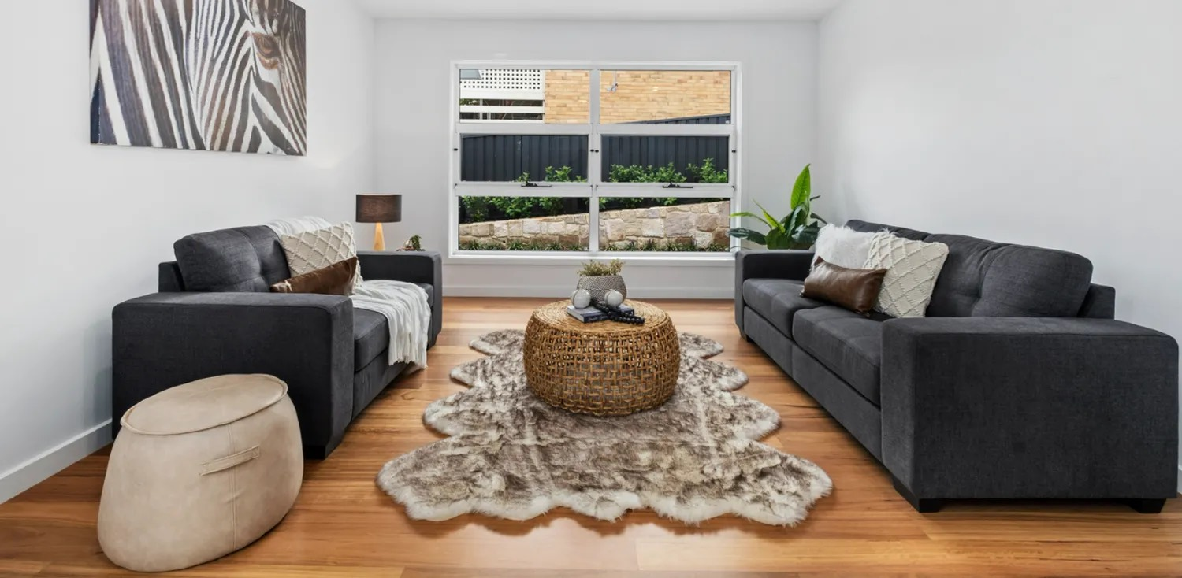 | 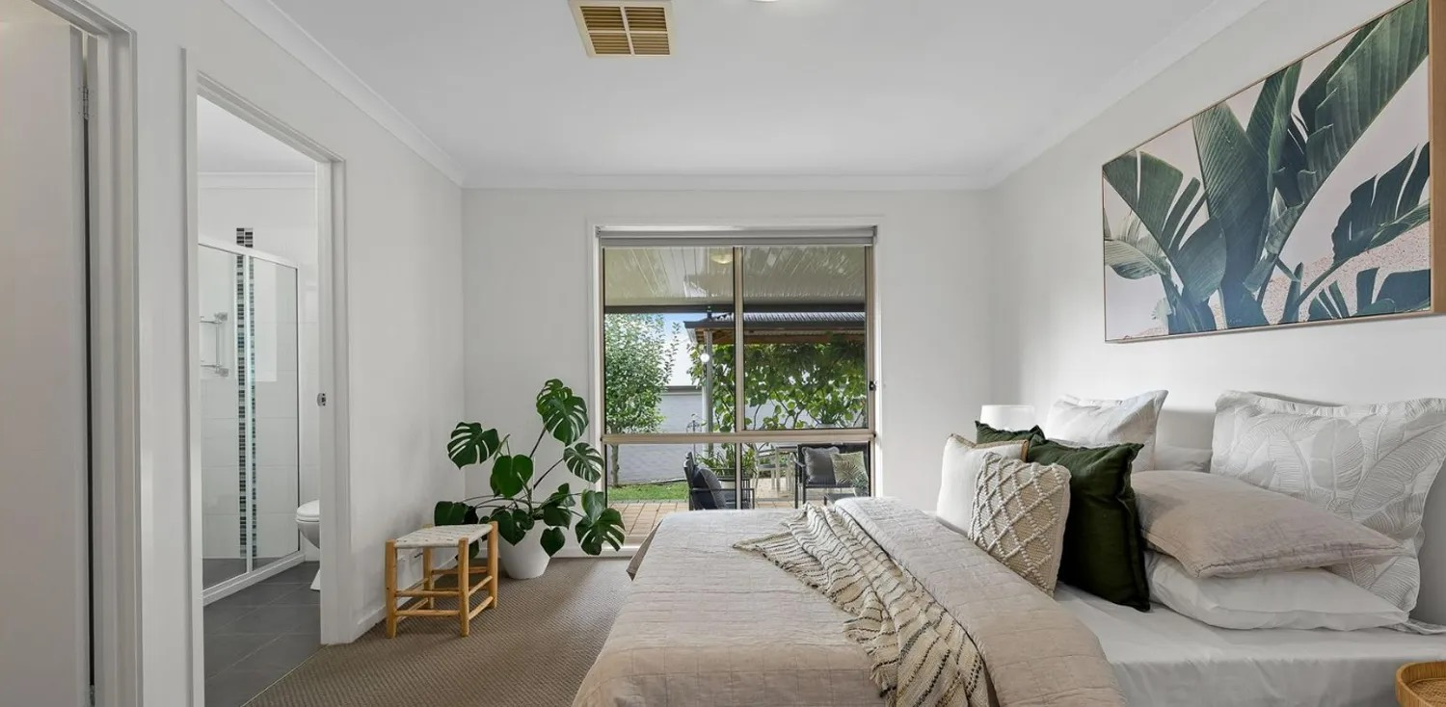

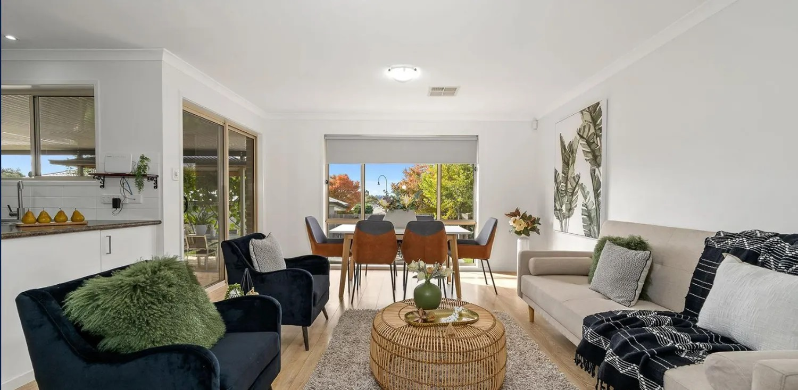
Recent campaign work from the Elements website.
5. Services
The same warehouse, truck and stock support every offer. Nothing below needs a second business to exist.
- Full styling for vacant or emptied homes — consult, specify, deliver, install, manage the campaign, collect.
- Partial styling, using what the vendor already has and filling the gaps.
- Consultations: placement, clutter, colour, lighting, what to pack away before photos.
- Style to Stay — living-in packages, and sometimes a furniture package that can stay with the purchaser.
- Display homes, apartments and marketing suites for builders and developers.
 | 

Service tiles from the current website — full styling and consultation.
Property | Guide | Typical rooms
1 bedroom | from $1,800 | Lounge, dining, bistro
2 bedroom | from $2,300 | Lounge, dining, bistro
3 bedroom | from $3,100 | Two lounges, dining, outdoor
4 bedroom | from $3,800 | Two lounges, two dining, outdoor

Published website guides. Extra spaces cost more. Payment before install, or on the vendor’s settlement.
6. How the week actually runs
Enquiry, quote, book the install, pull the rooms from the rack, truck out, style, photos, opens, collect when the campaign ends. Creative direction, styling, warehouse and administration are described as four functions. In practice the working owner still holds the creative and the agent relationships. Two stylists left this year — one moved, one started a design-and-build with her husband — so the next owner should plan to be on the tools, or to hire, rather than assume a full bench is waiting.
That is not hidden. It is why the handover is three months, not a set of keys in a car park.
7. Growth — if you want it
The obvious lever is utilisation: take the FY2024 run-rate and put it back on the same stock. After that, more of the existing agencies, more display work, Style to Stay, and a bit of digital presence the current owner never enjoyed. Neighbouring regional jobs are possible if the truck and the diary allow. None of that requires a second warehouse on day one.
8. Handover
The vendors will stay up to three months after settlement, on terms you agree. That can cover introductions to the main agencies, suppliers, the quoting and scheduling habits, inventory, and being on the end of the phone. Tricia is prepared to show how she has done it and then step back. If she is in Brisbane with family, some of that can be by video. Write the introductions into the contract as a number of meetings, not as ‘reasonable assistance’.
9. Process
- Confidentiality agreement.
- This memorandum, then financials, asset register, lease and inventory under due diligence.
- Warehouse viewing by appointment, outside install days if possible.
- Written offer. Asset sale contemplated: stock, vehicles, name, domain, phone, specified handover, non-compete.
- The vendors will not discuss the sale with referring agents until a contract is in place.
Figures here come from the vendors’ September 2026 portfolio and from a conversation with the working owner. Recipients should do their own work. This is not a forecast, a valuation, or tax advice. Do not copy, forward or use the trading name in a public advertisement without the vendors’ written consent.
Expressions of interest
Through the vendors’ appointed representative, once that appointment is made. Until then, treat this document as private.

